FOCP ASSIGNMENT 1

MODULE 5
Ques 6
perfect number

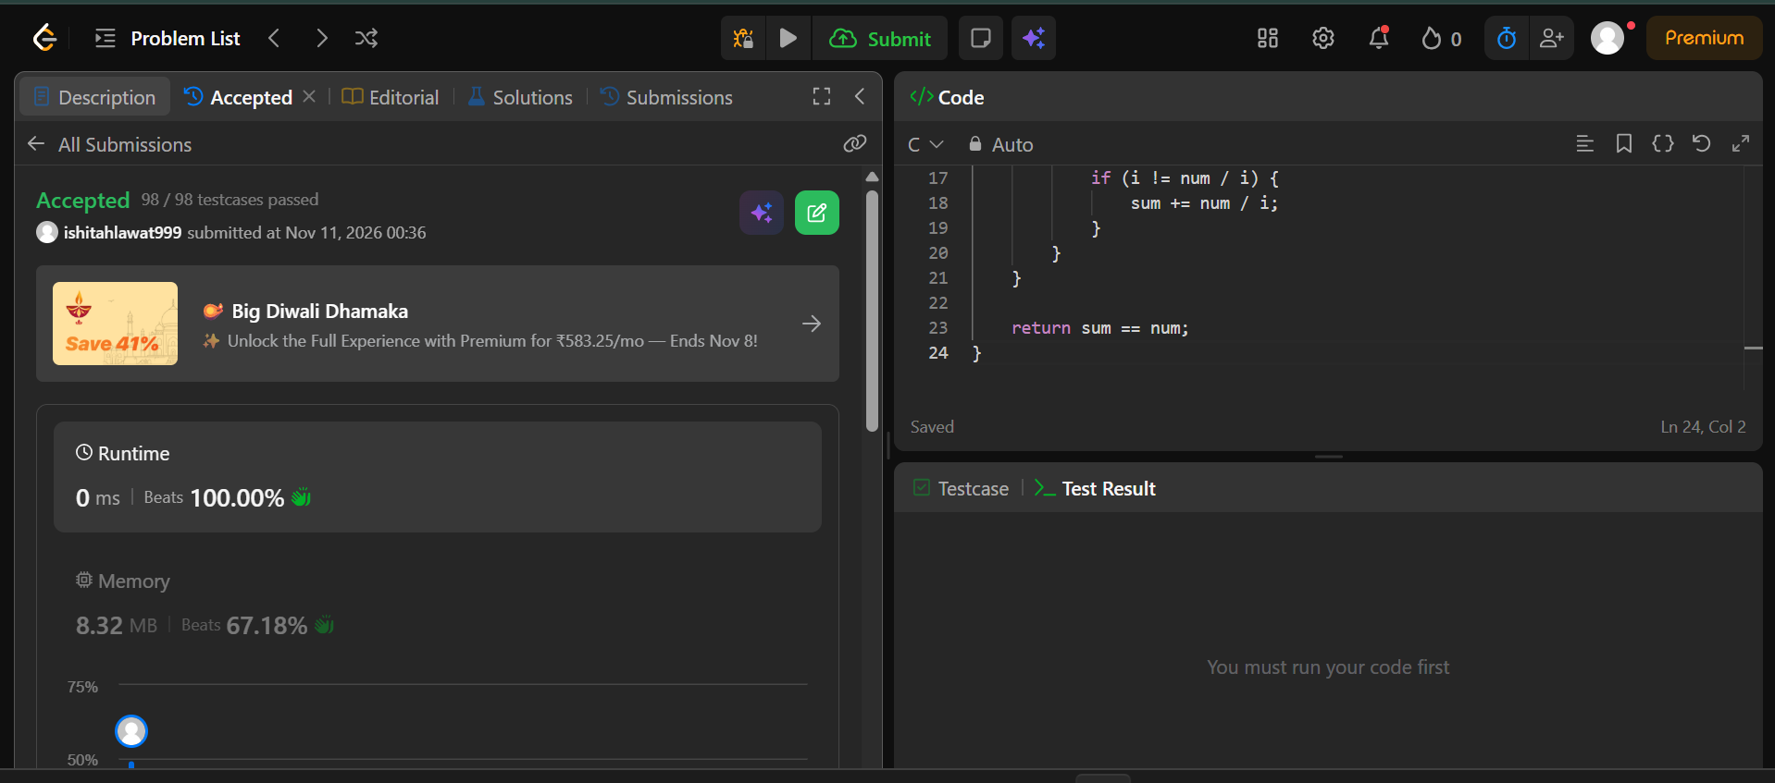

#include <stdbool.h>

bool checkPerfectNumber(int num) {
// Numbers <= 1 cannot be perfect numbers
if (num <= 1) {
return false;
}

int sum = 1; // 1 is always a proper divisor for num > 1

// Iterate only up to sqrt(num)
for (int i = 2; i * i <= num; i++) {
if (num % i == 0) {
sum += i;

// Add the paired divisor if it's different from i
if (i != num / i) {
sum += num / i;
}
}
}

return sum == num;
}

